Online Examination System

By: Mehak Basrani

IT-2K19-31

***Software Development Design***

Abstract:

ONLINE STUDENT TEST is a project developed to provide an easy way to develop student’s skills. This project helps users by analyzing the areas where students are weak and allows tests accordingly.

Introduction:

On-line Exam System is very much important for any Educational Organizations to prepare their students for any exams by saving the time. It will take check the paper and generate mark sheets as well. It will also help the Organization to test the students and develop their skills.

Purpose:

The purpose of Software Requirements Specification (SRS) document is to describe the external behavior of the Online Examination System. Requirements Specification defines and describes the operations, interfaces, performance, and quality assurance requirements of the Online Examination System. The document also describes the nonfunctional requirements such as the user interfaces. It also describes the design constraints that are to be considered when the system is to be designed, and other factors necessary to provide a complete and comprehensive description of the requirements for the software. The Software Requirements Specification (SRS) captures the complete software requirements for the system, or a portion of the system. Requirements described in this document are derived from the Vision Documentprepared for the Online Examination System.

Design and Implementation Constraints

The candidate is allowed to give the exams any number of times, until specified otherwise by the administrator while building the test. While giving the exam the candidate is given only a set amount of time and the remaining time should be displayed, after which the exam should close and display the result.

Use Case Diagram:

USER

Admin

Entity relation Diagram:

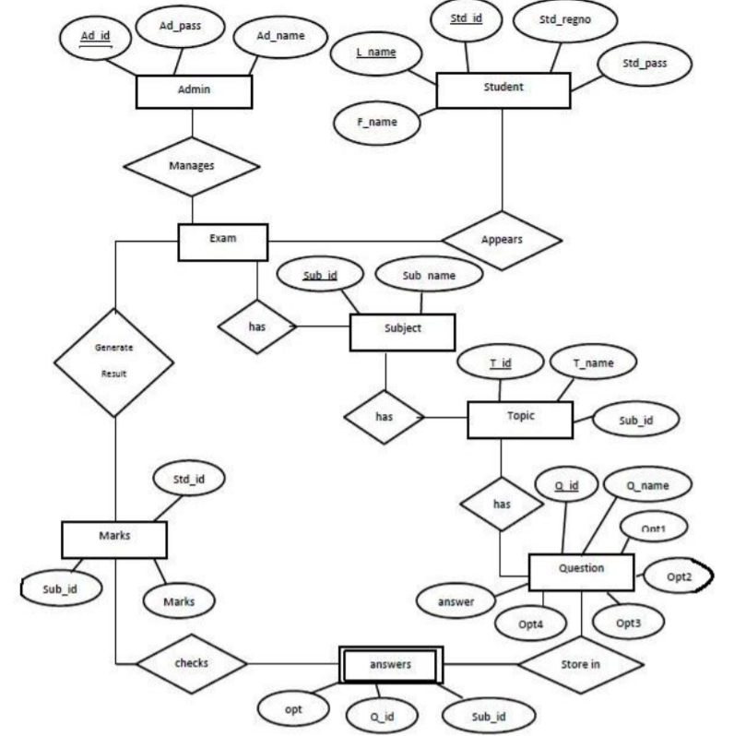

Data Flow Diagram:

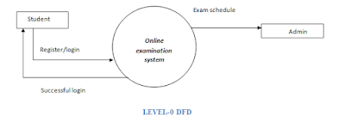

0 Level DFD

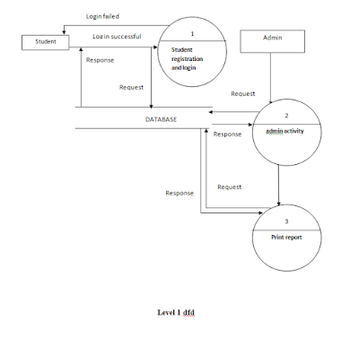

Level 1 DFD

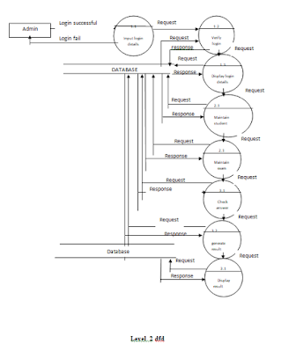

Level 2 DFD